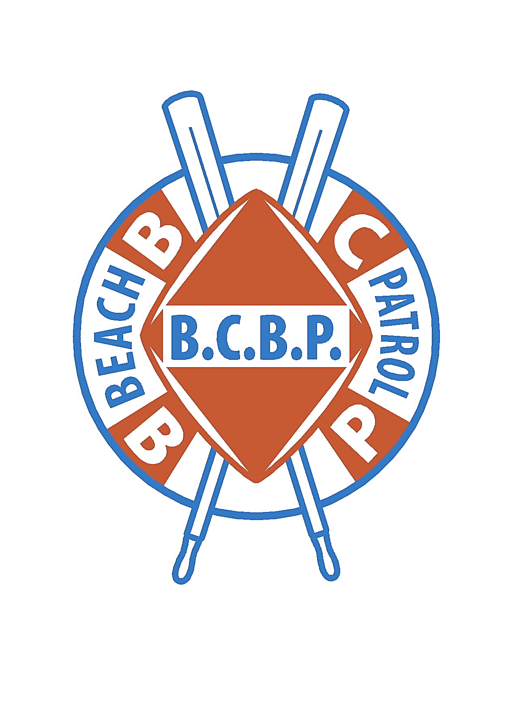

**The City of Brigantine**

**Ocean Front Lifeguard Test**

**Summer of 2022**

**Test Date:** Saturday**,** June 11, 2022 at BCBP HQ (17th St. South and Ocean Ave)

**Time:** 10:00 a.m. for Check in. Inclement weather date is Sunday, June 12, 2022.

**Requirements to take the Test:**

1. MUST be 16 years of age by August 1st of 2022.
2. MUST have a copy of a current physical (School physicals will be accepted).
3. Copy of Birth Certificate.
4. Signed Participation Waiver (If under 18, Parent/Guardian MUST sign)
5. Complete a City of Brigantine Work Application

**Applicants must be able to perform the following:**

* Run Test: Run 1 mile under a time of 7:30 minutes
* Swim Test: 500 meter Box Swim in the Ocean in 10:00 minutes or less.
* Paddle Board Test: Complete the Paddle Board Box course in the Ocean
* Surf Dash: Run 50 yards, Swim out to buoy and back to starting line.
* Interview: An in-person interview with BCBP Officers.

**Testing may be conducted at an alternate location depending upon Ocean conditions.**

**Items to bring with you:**

1. Running shoes
2. Swimsuit (no wetsuits permitted).
3. Towel
4. Goggles are permitted and recommended
5. Appropriate fitness clothes.

**Practice Camp:**

Practice sessions for the test will be administered on June 4th and 5th at 11:00 am at BCBP HQ (17th St. South and Ocean Avenue, Brigantine).

**BE ADVISED: If hired, attendance at ROOKIE TRAINING CAMP is mandatory.**

**If unable to attend, you will forfeit the opportunity to be a lifeguard.**

**These dates are TBD, more details will follow.**